Great Tyne Row

Sunday 23 August 2026

Information for Crews

Draft as at 27-04-26

N.B. See Terms and Conditions about how to enter and pay

1.0 Introduction
1.1 The Great Tyne Row is a 25 km journey of discovery. The event is organised by the Northern Rowing Council, in partnership with the British Rowing, Tyne Amateur Rowing Club (TARC), Tyne United Rowing Club (TURC), Tynemouth Rowing Club (TRC), Red Seal Rescue and the Sea Cadets.
1.2 This document should be read alongside other documents, especially the Navigation Guide (final version about a month before the event) and the Start Order (issued about a week before the event). These and other documents are or will all be on the event web site at www.greattynerow.com.
1.3 Queries about entries or other matters should be directed to Colin Percy, Event Director, at eventdirector.gtr@outlook.com or on 07985 003304.
1.4 All admin functions will run from Tyne ARC (NE15 8NL). Boating may also be from Tyne United RC (NE15 8NR) and Newburn Country Park slipway (NE15 8ND) - you will be notified which to go to. The detailed Day Plan (timetable) will on the web site about a week before the event, but the key timings for the day are likely to be as follows:
- Gates to these locations open (and food on at TARC): 08:00
- Registration: 09:00-10:15 at Tyne ARC
- Safety briefing: 11:00 (at least one per crew, preferably two)
- Boating: 12:15-13:00 (end time depends on number of entries)
- First division off: 12:45 (a little after high tide *)
- Last division off: 13:30 (exact time depends on number of entries)
- Finish (opposite north bank passenger ferry pier): 14:15 onwards
- Landing at Tynemouth RC: 14:30 onwards
- Prize-giving: 16:30 approx
- Food and bar available till 18:00 at Tynemouth RC (NE30 4DG)
* A very moderate high tide 3.87 metres is at about 13:40.
2.0 Trailers and car parking
2.1 START – There are up to three boating points (subject to number of boats): definitely TARC (north bank), possibly TURC (south bank) and, if there are fixed seat boats, at the slipway at the Newburn end of Tyne Riverside Country Park (north bank, further west). The first plan in the Navigation Guide shows the locations of these.
2.2 Each crew will be allocated one of these clubs to launch from in the final Start Order published about a week before the event. You will be able to access the clubs and slipway from 08:00 (slipway from 09:00) on the day of the event. Only trailers and towing vehicles will be able to get into the two rowing clubs. Crew etc cars must park in public car parks or, if done sensibly, on public roads. There is good public car parking next to the slipway. Further advice on access and parking will be given on the web site.
2.3 FINISH – Trailers (and towing vehicles if necessary) will be able to park at Priors Haven car park, situated just up the hill behind TRC from 08:00. To get there, find Tynemouth Priory, turn into the lane heading downhill and turn right just after the very narrow bridge. There is no charge; the car park is for exclusive use of Great Tyne Row vehicles. The car park is available all day so it’s up to you when you wish to bring the trailer over to Tynemouth. We will be able to help bring driver/rowers back to Newburn from Tynemouth at 10:00, but you must inform us in advance.
2.4 Note that Tynemouth may be busy if it’s a nice day and non-trailer vehicles may have to park some distance from the Rowing Club if arriving later in the day. Be warned!
3.0 Registration
3.1 Registration will start at 09:30 and be open till 10:30 at Tyne ARC on the north bank. You will be asked to confirm that crew members are as previously notified and that all are members of British Rowing or are otherwise covered by the third party liability insurance of another organisation or the individual themselves. You will also be asked to confirm you have the previously notified mobile phone with you to take in the boat.
4.0 Safety Briefing
4.1 The Safety Briefings will take place at TARC on the north bank at 11:00 - at least one crew member must attend and it is recommended you bring the cox plus one other.
4.2 At the safety briefing we will walk you through the Navigation Guide (please print out and bring with you). Particular attention will to be paid to the RED ZONES – these are the main commercial ship manoeuvring areas on the north side of the river and boats are not to enter into these areas unless otherwise instructed by a safety marshal.
4.3 At the end of the safety briefing you will be given a plastic number to fix to the bow (if visible only on one side, make sure it is on the starboard side (right side from cox’s point of view) and possibly a GPS tracker (tbc). The latter must be handed in at the finish - no tracker, no prize!
5.0 Clothing and changing facilities
5.1 Each crew member should ensure they are properly attired with consideration to the weather and water conditions, hot or cold, dry or wet. You should also ensure you have proper footwear for boating. Please note that wellington boots are good at the start to keep feet dry, but for disembarking on the beach at Tynemouth wellington boots are a total waste of time and you should wear trainers or sandals that you don’t mind getting wet.
5.2 There are changing facilities at the start clubs (but not the slipway) and at the finish host club. If you’d like to be able to change clothing at the conclusion of the event (recommended, as you may get wet landing if not before) we suggest you arrange with a family member or friend or your trailer driver to meet you at TRC with your change of clothes. This avoids having unnecessary items in the boat for the event. Get in touch if this is a real problem.
6.0 Food and refreshments
6.1 Breakfast and other food will be on sale from Tyne ARC from 08:00 and there is a cafe next to the slipway open from about 9.00am usually (but cannot be guaranteed).
6.3 Tynemouth RC will be having a barbeque with various foods for sale as well as having a licensed bar at the finish.
7.0 Start Procedure
7.1 Crews are responsible for getting on the river at the time to be notified in the final Start Order. Low numbers will boat first and you must boat when scheduled, otherwise following crews will be late for the start. We will not necessarily wait for late crews, so they could be very upset!
7.2 Provisional boating and start times are as follows, based on a good but not huge entry, so provisional. High tide (not a very big one - 3.87m) is about 13:40.
Division | Boating starts (order to follow) | Move to start area | 5 minute Warning | Start
1 | 12:15 | 12:35 | 12:40 | 12:45
2 | 12:30 | 12:50 | 12:55 | 13:00
3 | 12:45 | 13:05 | 13:10 | 13:15
4 | 13:00 | 13:20 | 13:25 | 13:30

7.3 The Navigation Guide will include the relevant plans and instructions, but (in outline) boats get on the water and stay in the boat holding area until 10 minutes before the start time. A marshalling launch will assist in moving you to the start, but it is your responsibility to be on the start on time; have a watch or other timepiece with you.
7.4 Once in the start area, boats should line up with bows staying behind the downstream end of the Newcastle University BC steps, where the start line is. There may be many boats in the start area, so please be tolerant of others and give each other space. You may have to start a few metres behind other boats - please bear in mind you have 25km to catch up! There will be a 5 minute warning (two short blasts on the horn) and then the start (verbal “Attention” and then one sustained air horn blast).
8.0 Navigation and emergencies
8.1 The journey from Newburn to Tynemouth is 25km in total. We estimate a range in times from 1hour 45 minutes to 3 hours. The overall route is shown in this map. The Navigation Guide has much more detail.

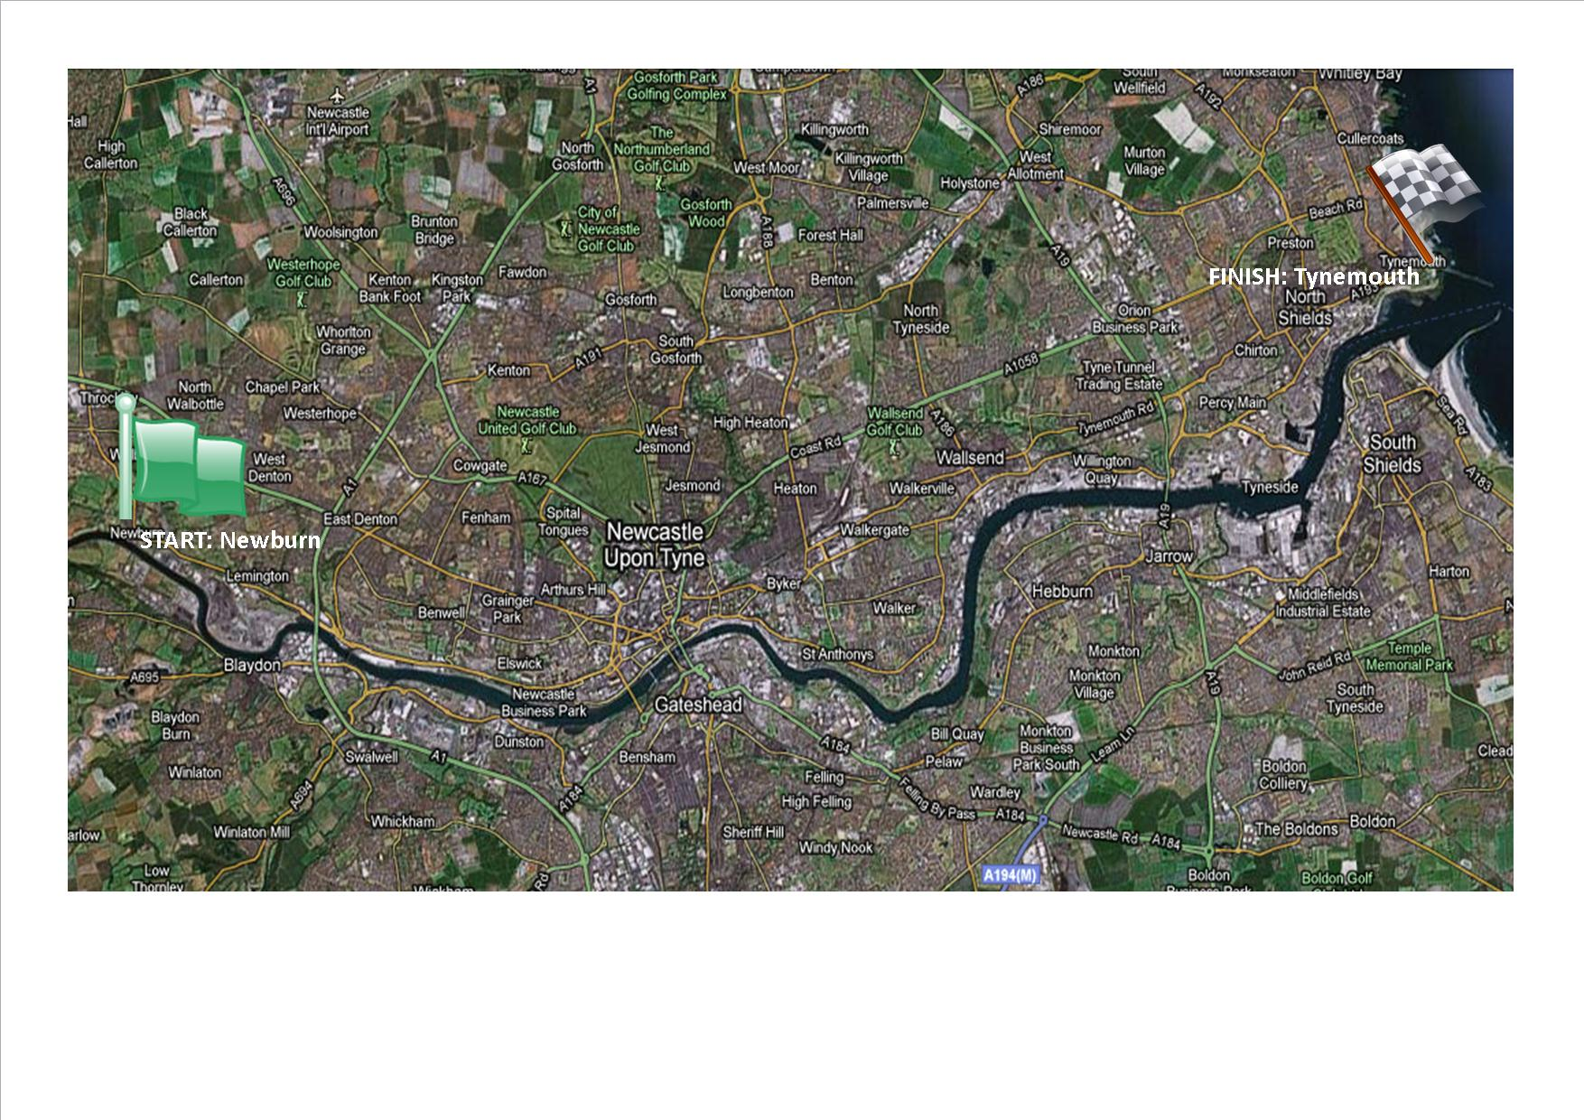

8.2 Throughout the event, safety launches will be on the water at locations stated on the Navigation Guide. They will attend any emergency situations on the water. You might wish to do any crew changes near one of these, but they cannot help unless it becomes an emergency! They may instruct you to deviate from the course or come to a halt. Please appreciate the complexities of rowing through commercial shipping lanes and follow their instructions efficiently and immediately.
8.3 In the event of an emergency, raise the alarm with your nearest safety launch or contact Event Control on 07985 003304 or the Director or Event Safety Adviser by VHF radio if you have one (channel to be advised). All crew members are to remain in/with the boat at all times unless otherwise instructed by a safety marshal. You shall be informed of all other relevant contact numbers during the safety briefing.
9.0 Presentation
9.1 Presentations will take place at Tynemouth RC at approximately 16:30. Awards are as follows.
Fastest Overall Boat, Overall Women’s Boat, Overall Fixed Seat & Overall Women’s Fixed Seat: each crew shall receive a Shield (to be returned to the event organisers the following year), pennant and bottle of fizz. Each crew member shall receive a glass tankard or similar. Crews can receive only one of these awards each.
Best Dressed Crew/Decorated boat: each crew shall receive a pennant and two bottles of fizz.
Harry Clasper Award: this award is presented at the discretion of the organising committee. It can be awarded under special circumstances to any crew or person; for example for being especially helpful to another crew or crews, rowing in challenging personal circumstances, etc. The crew or person shall receive a pennant and a bottle of fizz.
“Enjoying the View” (slowest boat): this is awarded to the crew who took their time to enjoy the view on the course and completed in the slowest time. The crew is awarded a pennant and a bottle of fizz.
Category prizes: for each category with more than one entrant, the fastest crew will receive a pennant and each crew member a glass tankard.
10.0 Spectating
10.1 We encourage supporters to cheer on the crews at Dunston about 13:00-14:00 then on or near the Gateshead Millennium Bridge in the centre of town about 13:30 to 14:45 and finally move down to Tynemouth RC. The boats will arrive at the Haven beach from about 14:45. If there is a strong wind from the east (unusual) then times will be later.

Colin Percy
GTR Event Director
Email: eventdirector.gtr@outlook.com
Mob: 07985 003304
Web: www.greattynerow.com
Facebook: www.facebook.com/greattynerow
Issued as a draft on 27-04-26

